**Application of WBS and Schedules**

**Introduction**

The WBS is the tool that is used to record and communicate the project deliverables (something produced or an outcome) and sub-deliverables as well as the accomplishments (something achieved) and sub-accomplishments. The identification of these elements relies on the *experience of the team members* as well as consultation with outside experts. Once the deliverables and accomplishments are listed, resources are determined for each element and sub-element.

A schedule is created from the WBS to ensure the project’s objective is accomplished in the time allotted. The first step in creating a schedule is an assessment of the critical path or the shortest period in which the project can be completed. Once the critical path has been established, start and end dates are assigned based on their relationship to the critical path.

***Work Breakdown Structure for the building of a table***

The first step in creating a WBS is identifying the project deliverables and sub-deliverables, and the achievements and sub-achievements. Each deliverable or achievement must equal the sum of its sub-elements. The WBS can be represented either as a list or graphically. Figures1 and 2 provide examples of a WBS for the building of a table.

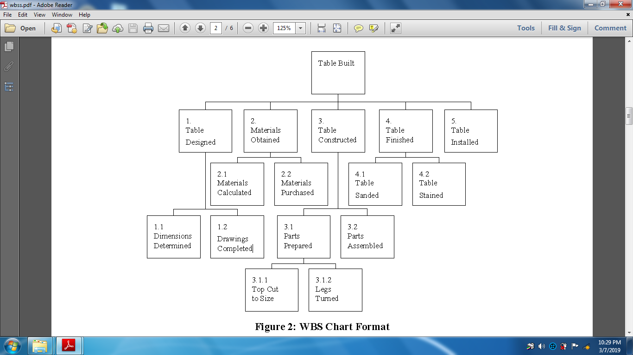**Work Break Down Structure (WBS)**

*Figure2: Examples of a WBS for the building of a table.*

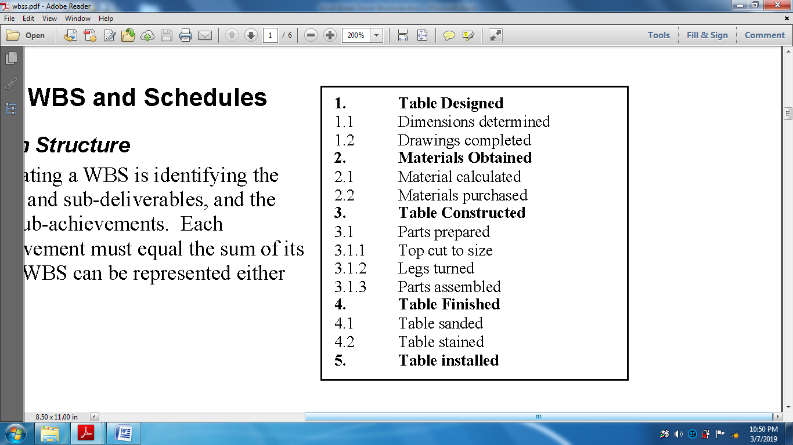

*Figure1: Examples of a WBS for the building of a table.*

***Task duration and dependencies***

***Tttttt pg 101***

***Determination of the Critical Path***

To determine the critical path of a project explores the *dependencies or relationships* between the elements within the WBS. The critical path examines the duration to complete tasks rather than the effort. This ensures that issues such as delivery lead time are taken into account when planning the project.

First, extract the steps to complete the project from the WBS. These will generally be the lower level elements of the WBS. Next, determine precedence or dependencies. It may be useful to sketch a diagram to help determine these dependencies. Figure 3 provides a very simple example where turning the legs of the table is considered to be one of the determining factors over the cutting of the table top.

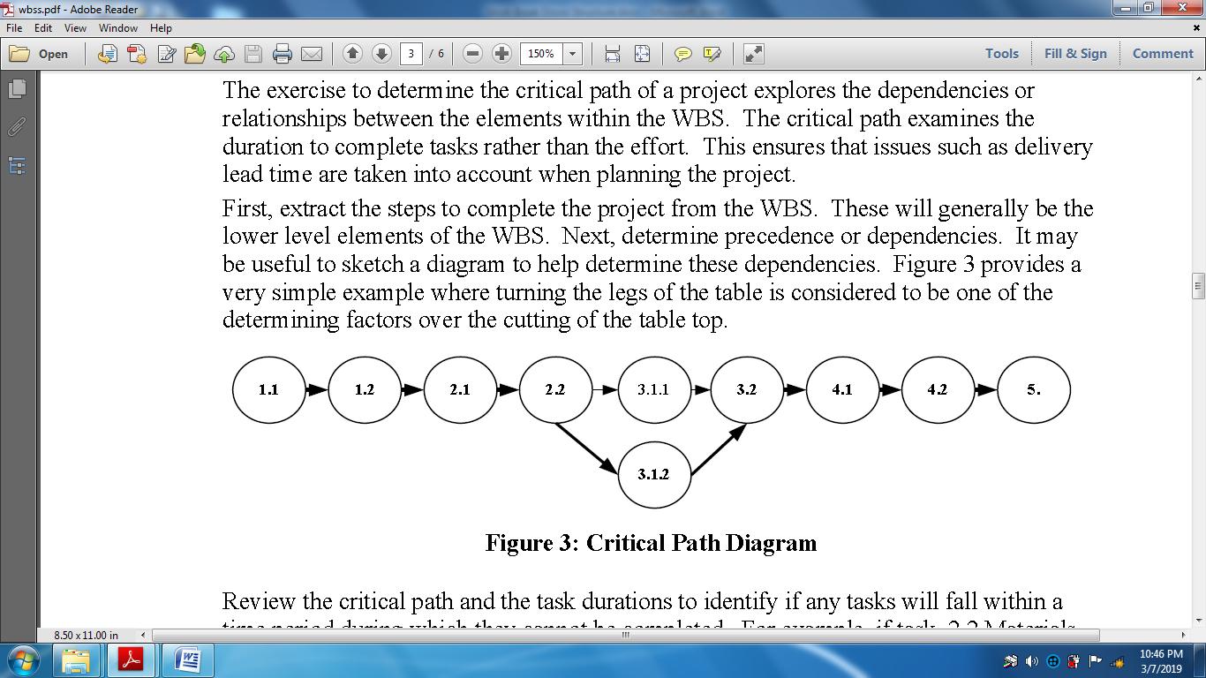

*Figure3: Critical path diagram*

***Creating the Schedule***

Once the WBS has been created and the critical path is determined, all the components are in place to create the schedule. Software such Excel Gantt Chart can be used to help develop the schedule but is not necessary.

If manually creating a schedule, list all of the project tasks roughly in order of precedence. For each task, indicate:

* Start date;
* End date;
* Duration;
* Percent Complete;

• ~~Effort;~~

• ~~Precedence relationship; and~~

~~• Name of person responsible for completing the task~~.

If desired, create a Gantt chart to graphically represent the schedule. A Gantt chart uses horizontal bars in a linear-type calendar. Figure2 provides an example of a schedule.

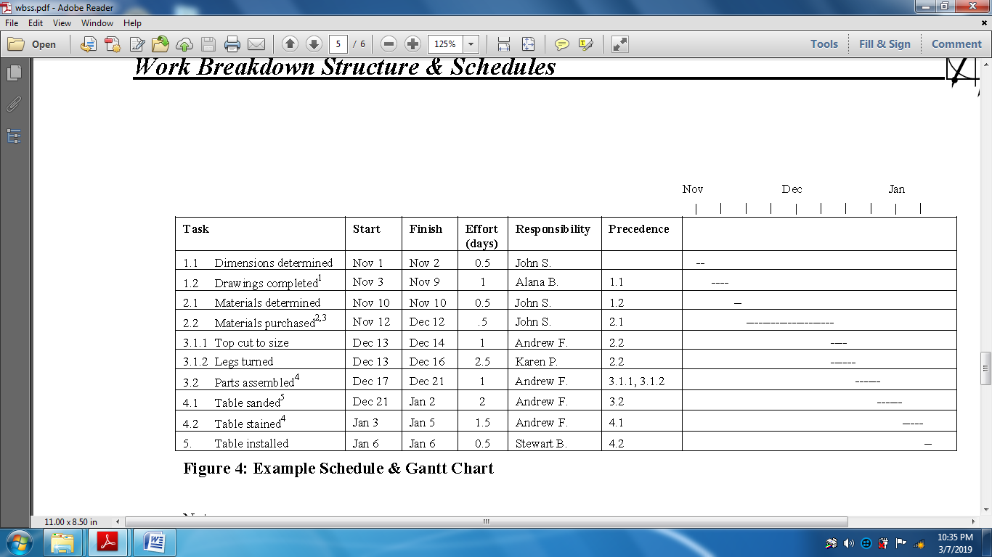

***Figure4: Example schedule and Gantt chart***